*The risks of shell-boring polychaetes to shellfish aquaculture in Washington, USA:*

*A mini-review to inform mitigation actions*

Short running title: *Minimizing impacts of shell-boring polychaetes*

Laura H Spencer1, Julieta C Martinelli1, Teri L King2, Ryan Crim3,

Brady Blake4, Heather M Lopes1,Chelsea L Wood1

1School of Aquatic and Fishery Sciences, University of Washington, Seattle, WA 98105

2Washington Sea Grant, University of Washington, Shelton, WA 98584

3Puget Sound Restoration Fund, Bainbridge Island, WA 98110

4Washington State Department of Fish and Wildlife, Olympia, WA 98501

Corresponding author: Laura H Spencer, lhs3@uw.edu

**Abstract**

In 2017, *Polydora websteri*, a shell-boring spionid polychaete worm and cosmopolitan invader, was identified for the first time in Washington State. *Polydora websteri* and some of its congeners bore into the shells of calcareous marine invertebrates, reducing the host’s shell integrity, growth, survivorship, and market value. Shell-boring *Polydora* spp. have a history of harming shellfish aquaculture industries worldwide by devaluing products destined for the half-shell market, and requiring burdensome treatments and interventions to manage against infestation. Here, we explore the risks of *Polydora* spp. to the historically unaffected aquaculture industry in Washington State. This mini-review is intended to inform shellfish stakeholders by synthesizing the information needed for immediate action in Washington State. We discuss *Polydora* life history andpathology, summarize the recent documentation of *Polydora* spp. in Washington State, and discuss its history as a pest species globally, including farm management strategies developed in other infested regions. Finally, we review existing regulations that may be leveraged by stakeholders to avoid introduction of *Polydora* spp into uninfested regions.

Keywords: Polydora, mudworm, invasive species, oyster

**Introduction**

In 2017, shell-boring *Polydora* spp*.* polychaete worms were positively identified in Washington State (Figure 1), including the cosmopolitan invader *Polydora websteri* (Martinelli *et al.*, 2019). These parasitic marine polychaetes in the family Spionidae bore into the shells of calcareous marine invertebrates, and may pose an economic and ecological risk to cultured and native shellfish species [(Lunz 1941; Simon and Sato-Okoshi 2015)](https://paperpile.com/c/RcvCBz/8XqE+F2RV). Prior to positive identification in 2017, no native or introduced shell-boring *Polydora* species had been described from Washington State (Martinelli *et al.* 2019; [Lie 1968)](https://paperpile.com/c/RcvCBz/yW9zY).

*P. websteri* is common to many other shellfish aquaculture regions [(Simon and Sato-Okoshi 2015)](https://paperpile.com/c/RcvCBz/F2RV), with a broad host range, including seven oyster, one mussel, and three scallop species [(Simon and Sato-Okoshi 2015)](https://paperpile.com/c/RcvCBz/F2RV). *Polydora* spp. are colloquially known as mud worms, or mud blister worms, and have a long history of reducing shellfish aquaculture production and value in regions such as Australia, New Zealand, South Africa, Chile, Mexico, the East and Gulf coasts of the United States, Hawaii, New Brunswick, and British Columbia (Table 1). Despite previous observations of *P. websteri* in nearby regions such as British Columbia [(Bower *et al.* 1992)](https://paperpile.com/c/RcvCBz/tkTE) and California (Hartman 1961), neither benthic surveys nor shellfish growers have historically identified shell-boring mud worms in Washington State. The worm’s local history, whether as an invader or a species that was not previously identified, and its state-wide infestation rates are unknown. The 2017 study reports that *Polydora* prevalence in Pacific oysters sampled from public beaches was as high as 53% in one embayment of South Puget Sound (Martinelli *et al.* 2019) and suggests that infestation rates may have recently increased to levels at which observers (e.g., growers, agency personnel) take notice. Ongoing work will determine infestation rates for the Salish Sea and Willapa Bay regions.

Given the negative impacts of *Polydora* spp.on shellfish aquaculture in other regions, its presence in Washington State warrants a region-focused review to inform further investigation and stakeholder awareness. Here, we explore *Polydora* spp. as a potential risk to Washington State aquaculture. We summarize *Polydora* pathology and life history, review the recent documentation of this pest in Washington State, discuss its history as a pest species, and finally outline measures that stakeholders can take to mitigate the risks and impacts of *Polydora* spp. to Washington State shellfish aquaculture given existing regulations.

**Host pathology**

Shellfish infected with boring *Polydora* spp. can have reduced shell integrity, growth, survivorship, and marketability [(](https://paperpile.com/c/RcvCBz/F2RV)[Morse *et al.* 2015](https://paperpile.com/c/RcvCBz/32wY); [Simon and Sato-Okoshi 2015)](https://paperpile.com/c/RcvCBz/F2RV). *Polydora* spp. worms bore into calcareous shells and line their tunnel with shell fragments, mucus, and detritus (Figure 2) [(Wilson 1928; Zottoli and Carriker 1974)](https://paperpile.com/c/RcvCBz/WIS1B+mYiIY). If the tunnel breaches the inner shell surface, the host responds by laying down a layer of nacreto protect itself from the burrow and the worm [(Whitelegge 1890; Lunz 1941)](https://paperpile.com/c/RcvCBz/3OMWW+8XqE). This can produce a blister, where a thin layer of shell lies over a mass of anoxic detritus. In oysters, the blister is unsightly, its contents malodorous, and if the blister is breached during shucking the detritus can contaminate oyster meat and brine, detracting from flavor and presentation ([Morse *et al.* 2015](https://paperpile.com/c/RcvCBz/32wY)). Burrows can also decrease shell strength, causing cracks during shipping and handling, and making shucking difficult (Bergman, Elner and Risk 1982; Bishop and Hooper 2005; Calvo, Luckenbach and Burreson 1999; Kent 1981). Since half-shell oysters are the most lucrative option for oyster farmers, and *Polydora*-infested oysters are often are not salable on the half-shell market, infestation significantly depreciates oyster products.

*Polydora* infestation can also devalue other oyster products by compromising growth and survival. *Polydora* worm burden is negatively correlated with growth rate, and while the mechanisms are not fully understood, this may be due to the energetic drain of nacre production [(Ambariyanto and Seed 1991; Boonzaaier *et al.* 2014; Handley 1998; Kojima and Imajima 1982; Lleonart *et al.* 2003a; Royer *et al.* 2006; Simon 2011; Wargo and Ford 1993)](https://paperpile.com/c/RcvCBz/fCuiB+UcuCB+6uzt+UbCiT+QfddC+kcElC). For instance, Pacific oysters (*C. gigas*) infested with *P. websteri* grow more slowly, exhibit more frequent but shorter valve gaping, and have higher blood oxygenation, a sign of metabolic changes [(Chambon *et al.* 2007)](https://paperpile.com/c/RcvCBz/dqCHX). Infested *C. gigas* also demonstrate a three-fold increase in abundance of Cytochrome P450, a protein involved in the oyster’s stress response, which could increase susceptibility to secondary stressors [(Chambon *et al.* 2007)](https://paperpile.com/c/RcvCBz/dqCHX). Shell strength is negatively correlated with *Polydora ciliata* burden in the mussel *Mytilus edulis,* which increases vulnerability to predation [(Kent 1981)](https://paperpile.com/c/RcvCBz/ncAce). Reproductive capacity can be altered by *Polydora*, for instance oocyte size was significantly reduced in infested *C. gigas* (Handley 1998). Interestingly, fecundity in the rock oyster *Striostrea margaritacea* increases with *P. websteri* infestation (Schleyer 1991)*.* The rock oyster could be exhibiting a response to stress from infestation by reproducing while resources allow it. Similar phenomena have been documented in nematode-parasitized mice, which produce larger litters than uninfected mice [(Kristan 2004; Schleyer 1991)](https://paperpile.com/c/RcvCBz/9CvPh+tuA23) and plants that prematurely reproduce (“bolt”) during periods of drought [(Barnabás et al 2008)](https://paperpile.com/c/RcvCBz/mUXd1). While mortality directly associated with *Polydora* infestation is not common, these studies indicate that shellfish harboring *Polydora* may be more susceptible to secondary stressors, including predation, disease, and environmental stress (Wargo & Ford, 1993).

***Polydora* life history**

The impact of *Polydora* on shellfish aquaculture arises from its life history as a shell-borer.After a planktonic larval stage, a burrowing *Polydora* worm settles onto the prospective host’s shell and begins building a tunnel [(Wilson 1928; Loosanoff and Engle 1943; Blake 1969a; Blake and Arnofsky 1999)](https://paperpile.com/c/RcvCBz/WIS1B+4Xo6+xO2XC+Mnlql). The worm enters along the margin of the shell and excavates its burrow toward the shell center, then often turns back toward the margin to create a characteristic U-shaped borrow (Figure 2). The worm secretes a viscous fluid to dissolve the calcium carbonate shell material, and uses its specialized segment, the 5th setiger, to stabilize its tunnel during burrowing [(Haigler 1969; Zottoli and Carriker 1974)](https://paperpile.com/c/RcvCBz/b4caa+mYiIY). The *Polydora* adult dwells within the tunnel, but can emerge from openings on the outer surface of the host’s shell to feed on particles in the water column and materials on the shell surface (Figures 2, 3) [(Loosanoff and Engle 1943)](https://paperpile.com/c/RcvCBz/4Xo6).

*Polydora* spp. reproduction has been thoroughly reviewed by Blake and Arnofsky (1999). Briefly, reproduction occurs when the male deposits sperm in a female’s burrow, and the female deposits egg capsules along the burrow wall, with each capsule containing dozens of eggs. Many species are capable of reproducing more than once during a season, and while species vary, one fecund female can produce hundreds of larval progeny (Blake 1969a; Blake and Arnofsky 1999). For instance, *P. websteri* females lay strings of approximately 10 capsules, each containing 50-55 eggs (Blake 1969a; Blake and Arnofsky 1999). Larvae hatch from eggs and emerge from their maternal burrow at the 3-chaetiger stage and are free-swimming until they settle onto a substrate [(Orth 1971; Blake 1969a)](https://paperpile.com/c/RcvCBz/EdUIq+xO2XC). Growth rate in the larval stage depends on ambient water temperature; thus, the time spent in the water column differs among species and across environmental conditions, and may last as long as 85 days [(Blake and Woodwick 1971; Blake and Arnofsky 1999)](https://paperpile.com/c/RcvCBz/Nhtei+Mnlql). This potential for a long pelagic larval duration, particularly in colder climates, may allow for long dispersal distances [(Simon and Sato-Okoshi 2015)](https://paperpile.com/c/RcvCBz/F2RV). Additionally, in some instances, early hatched larvae can feed on underdeveloped eggs (“nurse eggs”), and complete development in the burrow [(Haigler 1969)](https://paperpile.com/c/RcvCBz/b4caa). This could result in an individual host’s parasitic burden compounding over time due to high rates of autoinfection.

Understanding when planktonic *Polydora* larvae are most abundant in Washington State will be important for shellfish growers managing infestations, as *Polydora* colonize hosts during the larval phase. Generally, planktonic larval abundance tends to correlate with temperature and phytoplankton abundance, but temporal patterns vary geographically (Blake and Arnofsky 1999; Dorsett 1961). In Maine and New Zealand, *Polydora* larvae are reportedly only in the water column during spring and summer months (March to September) and in Maine peak abundance occurs in May and June (Blake 1969a; Blake 1969b; Handley and Bergquist 1997). In the Sea of Japan off the coast of Russia, *Polydora* spp. larvae are present year round, but abundance peaks in May, then persists at moderate levels through October (Omel’yanenko, Kulikova and Pogodin 2004). In the Gulf of Mexico, *Polydora* larvae are found in the water column year-round (Cole 2018; Hopkins 1958), and larval abundance peaks in May and/or November, depending on the location (Cole 2018). The breeding season can also vary within a region. For instance, in northern Japan (Hokkaido), *P. variegata* breeding occurs during the warmest months, from August to October (Sato-Okoshi, Sugawara, Nomura 1990). In contrast, in northeastern Japan, *Polydora* larvae (species not reported) are most abundant during winter and spring months, from December through June, and loosely coincide with phytoplankton blooms (Abe, Sato-Okoshi and Endo 2011). Although it has not been confirmed in the field, laboratory experiments indicate that diatoms may be an important larval food source for some *Polydora* species, as opposed to flagellates, and thus larval abundances or recruitment could coincide with diatom blooms (Anger, Anger and Hagmeier 1986).

How *Polydora* larvae select settlement locations is not understood. *Polydora* larvae are attracted to light (positively phototactic) during early stages, which is commonly leveraged to isolate polydorid larvae from plankton samples (Ye *et al.* 2017). *Polydora* readily recruit to dead oyster shells, so larvae probably do not respond to chemical cues from live hosts, but may respond to chemical or tactile signatures from shells (Clements *et al.* 2018). Some studies indicate that *Polydora* spp. may prefer to colonize certain mollusc species over others, possibly due to shell traits such as texture and size (Ambariyanto and Seed 1991; Lemasson and Knights 2019). Higher infestation rates were reported in *Ostrea edulis* compared to *C. gigas* (Lemasson and Knights 2019). Compared to *C. virginica,* however, *C. gigas* was more susceptible to *Polydora* infestation, which the authors attributed to the thinness of *C. gigas* shells (Calvo *et al.* 1999). Larger hosts are commonly infested with more worms. In the surf clam, *Mesodesma donacium*, infestation rates increase with size and juveniles smaller than 34 mm doe not harbor any *Polydora* spp., suggesting a shell size threshold for settlement (Riascos *et al.* 2008). Stressed or unhealthy hosts may be more prone to *Polydora* spp. infestation. When exposed to petroleum pollutants from the Providence River system, the hard clam *Mercenaria mercenaria* is more likely to be infested with *Polydora*; the authors suggest that the pollutants alter clam burrowing behavior, increasing the chances of *Polydora* colonization (Jeffries 1972). Finally, *Polydora* infestation may differ among locations due to environmental conditions, particularly salinity. A recent survey of wild *C. virginica* in two Gulf of Mexico estuaries found that *P. websteri* prevalence and abundance decrease with increasing salinity, with a marked drop in infestation at salinities exceeding 28 ppt (Hanley *et al.* 2019). High infestation rates were reported for *C. gigas* and *C. virginica* grown in low- and moderate salinity locations across Virginia, but infestation rates were much lower in areas with high salinity (Calvo *et al.*1999). *Polydora* infestation has also been associated with low-salinity environments in the Indian backwater oyster *C. madrasensis* (Stephen 1978). In Gulf of Mexico farms, *P. websteri* was reportedly least abundant in *C. virginica* where salinity was most variable (Cole 2018). Whether salinity influences the current *Polydora* spp. distribution and abundance in Washington State is not yet clear.

**Recent *Polydora* identification in Washington State**

Historically, Washington shellfish farmers have not reported losses from shell-boring *Polydora* on their farms, and until recently no shell-boring *Polydora* species had been formally documented from the state. Related spionid polychaetes have been present, such as *Polydora cornuta* (Fermer & Jumars 1999), *Pseudopolydora* spp. (e.g*.* Woodin 1984), and *Boccardia proboscidea* (Hartman 1940, Oyarzun *et al.* 2011). These are primarily benthic species, and while they can occupy mud deposits within oyster shell crevices, they do not burrow and therefore do not create blisters.

In 2017, mud worm blisters were noticed in increasing abundance in cultured Pacific oysters from southern Puget Sound, which triggered a preliminary survey. Martinelli *et al.* (2019) sampled Pacific oysters from public beaches in Totten Inlet and Oakland Bay (Figure 1). Across the two sites, 41% of oysters were infested with a shell-boring worm (53% of Oakland Bay oysters, 34% of Totten Inlet oysters) (Martinelli *et al.* 2019). The worm species was identified using morphology (from scanning electron microscope images), and phylogenetics (comparing 18s rRNA & mtCOI sequences against published *Polydora* sequences). Some of the worms collected from Oakland Bay were positively identified as *P. websteri*, while others did not group with any of the available sequences and their identity remains unresolved (phylogenetic trees from Martinelli *et al*. 2019 are reproduced in Figures 4 & 5).

It is unknown whether *P. websteri* was historically present in Washington State at low abundance or recently introduced. If the species was recently introduced, eradication might be possible (see Williams & Grosholz, 2008 for examples of successful programs). But if eradication of *P. websteri* is not possible, it could still be contained to a few Puget Sound basins through education, mitigation, and regulation [(Çinar 2013; Paladini *et al.* 2017)](https://paperpile.com/c/RcvCBz/pTz3+ly4P+Exfx). If *P. websteri* has been present but dormant, the high infestation intensity reported by Martinelli *et al.* (2019) may be the result of a recent outbreak, caused by factors such as genetic changes, relaxation of biotic pressures (e.g. predators), or environmental changes (e.g., ocean warming, siltation) (Crooks 2005; Clements *et al.* 2017a).

Washington State aquaculture produces 45% of the molluscs cultured in the U.S. (2013, USDA) and is an iconic industry that supports rural communities, protects water quality, and collaborates closely with research and restoration programs. Within Washington, Puget Sound growers produce 70% of the state’s shellfish (80% by value, over $92 million annually), concentrated mostly in South Puget Sound, where the *Polydora*-infested oysters were sourced (Figure 1). Economic losses associated with *Polydora* outbreaks in this highly productive shellfish region could have nation-wide repercussions for the aquaculture industry.

**Impacts to aquaculture production**

*Polydora* has caused economic losses for shellfish aquaculture operations worldwide. Of the shell borers, *P. websteri, P. ciliata,* and *P. hoplura* are the most widely distributed and notorious for infesting shellfish farms [(Radashevsky *et al.* 2006)](https://paperpile.com/c/RcvCBz/5znG) (Table 1). The primary impact is product devaluation due to negative consumer responses to blisters and anoxic material within the inner shell, particularly in freshly shucked oysters [(Shinn *et al.* 2015)](https://paperpile.com/c/RcvCBz/UtJP). In rare instances, large mortality events have been attributed to *Polydora* infestation. For instance, in British Columbia, *P. websteri* caused up to 84% mortality in scallop grow-out sites from 1989 to 1990, resulting in up to US $449,660 in lost revenue that year [(Shinn *et al.* 2015; Bower *et al.* 1992)](https://paperpile.com/c/RcvCBz/UtJP+tkTE). In Tasmania and South Australia, *P. hoplura* killed over 50% of abalone stocks between 1995 and 2000, causing an estimated US $550,000 to $1.16 million in losses per year [(Shinn *et al.* 2015)](https://paperpile.com/c/RcvCBz/UtJP). In the summer of 1997, one million juvenile scallops were culled in a Norwegian nursery due to a *Polydora* spp. infestation; as a result, one-third of Norway’s 1997 scallop cohort was lost [(Mortensen *et al.* 2000)](https://paperpile.com/c/RcvCBz/GeoC2). In 1998, intense infestations (up to 100 worms per oyster) of *P. ciliata* in *C. gigas* oysters in Normandy, France correlated with considerable reduction in growth and meat weight, which may have contributed to unusually high summer mortality rates of up to 51% [(Royer *et al.* 2006)](https://paperpile.com/c/RcvCBz/AtYlO).

In other regions, *Polydora* infestations have made certain growing practices impractical or unprofitable. In New Zealand, fattening intertidally-grown oysters in longlines for a few weeks prior to sales improves oyster condition, but this practice is not recommended due to the risk it entails of *Polydora* spp. infestation (Curtin 1982). Following the collapse of native *C. virginica* in North Carolina, triploid *Crassostrea ariakensis* were assessed for culture. Feasibility was contingent on harvesting oysters prior to summer months to avoid *Polydora* colonization, as revenue would be lost if infestation rate exceeded 54% (Bishop & Peterson 2005; Grabowski *et al.* 2007). Many regions have experienced chronic *Polydora* infestation for decades (*e.g*., South Africa and New South Wales, Australia). Growers incur costs associated with cleaning or treating stocks to control *Polydora*, and having grow-out methods restricted to specific high tidal heights or locations, but these economic impacts have not been quantified.

**Management strategies developed in other regions**

In regions with noxious *Polydora* spp., producers control infestation by modifying gear and grow methods, and treating shellfish stocks regularly. Farm management approaches focus on keeping oysters free of mud and air drying oysters by growing them at high tidal elevations ([Morse *et al.* 2015](https://paperpile.com/c/RcvCBz/32wY); Handley & Bergquist, 1997). Since the early 20th century, Australian oyster farmers in New South Wales have used off-bottom growing methods with long tidal exposures to reduce mud worm infestation rates (Smith 1981; Diggles 2013; [Ogburn 2011)](https://paperpile.com/c/RcvCBz/yJ0u+32wY). Oysters are grown at approximately the mean low water neap height using rack and rail, long-line, and elevated tray systems, such that stocks are exposed for 30 percent of each daily tidal cycle (Ogburn 2011). On the U.S. Atlantic Coast, researchers report that exposing *C. virginica* for 40 percent of a tidal cycle is an effective method of avoiding substantial *Polydora* infestation (Littlewood *et al.* 1992). Growing oysters in bags that are easily raised above the water line for aerial exposures can also reduce infestation rates, particularly during the *Polydora* breeding season. For instance, some growers on the U.S. Gulf Coast use floating cages and rack-and-rail systems to easily expose bags weekly for up to 24 hours (Gamble 2016; Cole 2018). These off-bottom methods have proven effective for avoiding high rates of infestation, but do slow oyster growth rates [(Ogburn *et al.* 2007; Nell 2007; Nell 2001)](https://paperpile.com/c/RcvCBz/yJ0u+pnEn+7Oex), and do not always prevent infestation (Cole 2018; Clements *et al.* 2017a). For instance, recent *Polydora* outbreaks were reported in oysters suspended off-bottom in New Brunswick, Canada and may have been related to high siltation levels, which can increase *Polydora* infestation rates (Clements *et al.* 2017a). Increasing cleaning frequency to reduce siltation may therefore help to control *Polydora*, particularly in areas with heavy siltation. Frequent cleaning can also reduce impacts of non-boring *Polydora* species, such as *P. nuchalis* and *P. cornuta,* which foul culture equipment with large masses of sediment and tubes [(Bailey-Brock 1990)](https://paperpile.com/c/RcvCBz/fHEw).

A variety of treatments have been developed to kill worms in oysters infested with *Polydora* spp. Methods include freshwater soaks (up to 72 hours), salt brine soaks (up to 5 hours), extended cool air storage (up to 3-4 weeks at 3°C), heat treatments (e.g., 40 seconds at 70°C), chemical treatments (e.g.,chlorine, iodine), and various combinations thereof. Treatment efficacy can differ among species, season, and exposure duration, but generally the most commonly used treatments are hyper-saline dips followed by air drying, and extended cold-air storage. For Washington State growers, hyper-saline dips followed by air drying may be a feasible treatment regime, but precise methods will need to be developed for local conditions and species. For *C. virginica* and *C. ariakensis* grown in North Carolina*,* weekly treatments using a 20-minute hypersaline dip followed by air drying for 2 hours reduced *Polydora* spp. infestation to only 5% from up to 47.5% in untreated oysters (Bishop and Hooper 2005). Currently, the most effective treatment appears to be the “Super Salty Slush Puppy” (SSSP), first developed by Cox *et al.* [(2012)](https://paperpile.com/c/RcvCBz/IbKwa). The protocol involves a 2-minute full submersion of oysters in brine (250 g/L) between -10°C and -30°C (i.e., ice-water), followed by air drying for 3 hours. The SSSP also effectively kills other fouling epibionts, such as barnacles. Petersen [(2016)](https://paperpile.com/c/RcvCBz/s92BU) recently compared the SSSP method against other saltwater, freshwater, and chemical dips followed by air exposure for infested *C. gigas*, and confirmed SSSP as the best method, killing 95% of *P. websteri* while causing only minimal oyster mortality*.*

Freshwater immersion is another treatment option for Washington growers, and for some host or polychaete species, may be more effective than hypersaline dips. For Chilean flat oysters (*Tiostrea chilensis*), freshwater immersion for 180-300 minutes was more effective than hypersaline immersion (64 ppt) at killing *Boccardia acus*, another shell-boring polychaete species (Dunphy, Wells and Jeffs 2005). In heavily infested *C. virginica,* nearly 98% *Polydora* mortality was achieved with a 3-day freshwater immersion followed by four days of cold-air storage (Brown 2012). Without the cold-air storage, the freshwater immersion only killed 25-60% of *Polydora*, and worms occupying deep burrows were unaffected (Brown 2012). Interestingly, worms that were removed from burrows and placed in freshwater were killed within three days, which highlights the protection that shell burrows provide for *Polydora* worms (Brown 2012). In other regions, chemical treatments have effectively controlled *Polydora* infestation (Gallo-Garcia *et al.* 2004). However, environmental and health and safety regulations will probably preclude chemicals from being used in Washington State (Morse *et al.* 2015).

Treating infested oysters mitigates the effects of severe infestation, but costs may be prohibitive. Growers incur expenses associated with handling and specialized equipment (Nell 2007). Modifying grow methods to accommodate frequent *Polydora* treatments, or to minimize secondary stressors following treatments, may also be necessary. Treatment costs also depend on reinfection rates, which occur more readily on farms that harbor *Polydora* reservoirs, such as dead oyster shell or wild shellfish growing nearby (Clements *et al.* 2018; Lemasson and Knights 2019). Many of the existing treatments have been developed for species not commonly grown in Washington State. A common treatment for *C. virginica* is long-term cold-air storage. Maine growers have found that after 3-4 weeks (~3°C), 100% of adult *Polydora* worms are killed, with minimal *C. virginica* mortality (Morse *et al.* 2015). Prolonged air exposure is also commonly used for the Australian oyster *Saccostrea glomerata* (7-10 days, in the shade; Nell 2007). These oyster species have different physiological tolerances than *C. gigas*, the dominant aquaculture species in Washington, and therefore the same treatments may not be feasible for many of the state’s oyster growers (Morse *et al.* 2015; Nell 2007). For instance, while *C. virginica* can survive cold-air storage for six months with ~80% survival, no *C. gigas* seed or adults survived similar cold-air conditions after 20 weeks of storage (Hidu, Chapman and Mook 1998). Irrigating stored *C. gigas* continuously with seawater can increase survival in cold air storage (52% adults and 80% juveniles at 7°C), but whether irrigation also increases *Polydora* survival is not known (Seaman 1991).

Oyster mortality can be an issue following treatments for *Polydora* (Nell 2007). Growers are highly encouraged to test treatments on a small number of oysters before applying it to large batches (Morse *et al.* 2015). Making adjustments to grow methods might be necessary to improve oyster survival following treatments. For instance, increasing flow rates in a nursery upweller system can increase *C. ariakensis* and *C. virginica* survival following hypersaline and drying treatments (Bishop and Hooper 2005). More details and recommendations for treatment options are available in Morse *et al.* (2015) and Nell (2007).

It is important to recognize that the majority of treatments to kill *Polydora* have been developed for oysters (but see Bilbao *et al.* 2017 and Lleonart, Handlinger & Powell 2003b for abalone treatments). Shellfish species that are sensitive to exposures cannot be treated using these extreme methods, and therefore are vulnerable to infestation and may provide refuge to *Polydora*. Finally, no method to date has assessed whether these interventions render *Polydora* eggs inviable, which is an important question that needs to be answered.

***Polydora* introduction via shellfish translocation**

*Polydora* spp. have a long history of accompanying shellfish during translocation and becoming invasive pests. In the early 1880’s, oysters believed to have been infected with *P. ciliata* were imported from New Zealand into the George’s River in Southeast Australia. Before being sold in Australian markets, they were routinely refreshed or fattened in bays adjacent to native shellfish beds (Roughley 1922; Edgar 2001; Ogburn 2007). By 1889, mud worm outbreaks had infected thirteen separate estuaries in the region, and oyster growers abandoned leases that were below the low-water mark (Roughley 1922). The introduction and translocation of mud worm species to Australia may have contributed to the disappearance of native subtidal oyster beds (*Saccostrea glomerata*, *Ostrea angasi*), some of which never recovered [(Diggles 2013; Ogburn 2011)](https://paperpile.com/c/RcvCBz/LMsc). More recently, *Polydora* spp. were introduced into Hawaii, probably from stock shipped from mainland United States or Mexico [(Eldredge 1994)](https://paperpile.com/c/RcvCBz/Kv1B). In one notable case, *P. websteri* brought to Oahu via California oyster seed resulted in a severe infestation, and caused farmers to abandon their land-locked oyster pond [(Bailey-Brock and Ringwood 1982)](https://paperpile.com/c/RcvCBz/BK00).

When invasive *Polydora* spp. are introduced to new regions, they can disperse during their planktonic larval stage to infect other shellfish within a basin [(Simon and Sato-Okoshi 2015; Blake and Arnofsky 1999; David *et al.* 2014; Hansen *et al.* 2010)](https://paperpile.com/c/RcvCBz/F2RV+Mnlql+xatTF+cShko). As shellfish farmers grow oysters in high-density bags, racks, or lines, a *Polydora* infestation can spread readily within a farm, and the subsequent movement of stock is considered the primary pathway for *Polydora* introduction into new regions [(Simon and Sato-Okoshi 2015; Moreno *et al.* 2006)](https://paperpile.com/c/RcvCBz/F2RV+JyHC). *Polydora* worms do not usually kill the host, nor do they inhabit living host tissue, so infections can go undetected via traditional disease screening and may not be recognized until an area is fully infested [(Korringa 1976)](https://paperpile.com/c/RcvCBz/3nY2d). The infection mechanism might explain why *Polydora* spp. were found to be very prevalent in the year in which the infections were first reported from Puget Sound (up to 53% of *C. gigas* infected in Oakland Bay) (Martinelli *et al.* 2019). Many *Polydora* species have broad host ranges, making it possible for all cultured shellfish species in Washington State to be infested, including the native Olympia oyster (*Ostrea lurida*) and introduced *C. gigas*, *C. virginica*,and *C. sikamea*. Furthermore, *Polydora* species can persist in non-cultured reservoir hosts, regardless of growers’ control treatments, making it difficult to eradicate from a farm [(Moreno *et al.* 2006)](https://paperpile.com/c/RcvCBz/JyHC).

**Examples of *Polydora* monitoring and regulations globally**

In Australia, *Polydora* spp. have been common since they were introduced in the late 1800’s, and are not identified as invasive species but are considered pests to abalone and oyster growers. In New South Wales, the Department of Primary Industries continues to develop and test control measures for shellfish farmers [(Nell 2007)](https://paperpile.com/c/RcvCBz/pnEn). In 2005, Tasmania developed a comprehensive management program for mud worm control in cultured abalone in response to outbreaks [(Handlinger *et al.* 2004)](https://paperpile.com/c/RcvCBz/G0fc). In Victoria, Australia, the Abalone Aquaculture Translocation Protocol categorizes mud worms as a “significant risk”, and now regulates the movement of infected stock to uninfected areas [(Victorian Fisheries Authority 2015)](https://paperpile.com/c/RcvCBz/6dYqJ). In New Brunswick, Canada the Canadian Aquaculture Collaborative Research and Development Program (ACRDP) recently funded a project to identify potential causes of increasing, sporadic *P. websteri* outbreaks in off-bottom oyster sites. Despite Canada characterizing *Polydora* spp. as a Category 4 species of “negligible regulatory significance in Canada,” the recent outbreaks raise questions about the potential for *Polydora* spp. intensity to shift geographically and over time, particularly in response to changing climate conditions [(Government of Canada and Services 2017)](https://paperpile.com/c/RcvCBz/S5kA).

**Status of *Polydora* monitoring and regulations in the USA**

Marine polychaete species, including shell-boring *Polydora* spp., are not monitored or regulated in the United States. According to a 2013 review, 292 polychaete species (15% of all described polychaetes) have been relocated to new marine regions via human transport. Of these, 180 are now established and 16 are in the genus *Polydora* [(Çinar 2013)](https://paperpile.com/c/RcvCBz/pTz3). Despite this, there is no international or national governing body regulating this transport, and aquatic parasites are not recognized as invasive or injurious species in the United States. For example, the U.S. Geological Services list of Nonindigenous Aquatic Species includes only two annelids, both freshwater species [(USDI](https://paperpile.com/c/RcvCBz/n8ZkV) n.d.[)](https://paperpile.com/c/RcvCBz/n8ZkV). While the United States Department of Agriculture’s 2017 reportable disease list does include seven molluscan parasites, it does not include shell-boring polychaetes [(USDA](https://paperpile.com/c/RcvCBz/fS4Sr) 2017[)](https://paperpile.com/c/RcvCBz/fS4Sr).

The ubiquity of *Polydora* species and their long history as pests in the Atlantic and Gulf Coasts may be the reason for this lack of federal regulation ([Lunz 1941; Lafferty and Kuris 1996](https://paperpile.com/c/RcvCBz/XYJg+LCY4+YZpv+8XqE)). Nevertheless, researchers and government agencies continue to help Atlantic and Gulf farmers control infection. In the past five years, the Maine Sea Grant [(Morse *et al.* 2015)](https://paperpile.com/c/RcvCBz/32wY), Alabama Cooperative Extension System [(Walton *et al.* 2012; Gamble 2016)](https://paperpile.com/c/RcvCBz/ymdz+fA8z), New Jersey Sea Grant [(Calvo *et al.* 2014)](https://paperpile.com/c/RcvCBz/KAF1), and the USDA Sustainable Agriculture Research & Education (USDA Grant no. FNE13-780) invested in communication tools and methods for farmers to mitigate the effects of mud worm on their shellfish products. These investments highlight that *Polydora* is an ongoing, real issue for farmers in infected regions, and that Washington growers may need to respond if *Polydora* prevalence continues to increase in the state.

**Live shellfish regulations in Washington State**

In Washington State, regulations are in place to avoid introducing diseases and invasive species, which are identified in the Washington Administrative Code (WAC). Here, we review existing Washington State code to highlight regulations that control the spread of invasive species throughout the state, which may be leveraged to limit movement of shellfish heavily infested with *Polydora* spp. to uninfected regions, if warranted.

Under WAC 220-340-050 and WAC 220-370-200, import permits are mandatory for any entity importing live shellfish from outside Washington State for any purpose, such as aquaculture, research, or display, but excluding animals that are market-ready and not expected to contact Washington waters. Import permits require a “clean bill of health” certifying that the origin is disease-free, and free of the invasive green crab (*Carcinus maenas*) and oyster drills (*Urosalpinx cinerea* and *Ocinebrellus inornatus*). The WDFW import permits can require that clam, oyster, and mussel seed or stock intended to touch Washington waters be treated for the invasive green crab using a dilute chlorine dip ([WDFW, n.d.)](https://paperpile.com/c/RcvCBz/sHSc); this treatment may be effective against shell-boring species such as *Polydora* spp., but has yet to be tested. In instances where the chlorine dip is lethal (e.g., mussels and geoduck), imports are only allowed from locations isolated from European green crab-infested waters, and thus the treatment is not required. The chlorine dip has not been evaluated for use against *Polydora*. If effective, it could be adopted as a treatment required by WDFW when translocating stocks from areas with heavy *Polydora* infections. Transfer permits are also required under WAC 220-340-150 when moving adult shellfish and seed between and within Washington State basins. These permits are regulated by the Washington State Department of Fish and Wildlife (WDFW). Oyster shell (cultch), which is moved throughout the state for oyster bed enrichment and hatchery seeding for farming and restoration purposes, is required to be "aged” out of the water for a minimum of 90 days and is inspected by WDFW prior to placement into state waters, so it is unlikely to translocate viable *Polydora* worms or eggs (WDFW, personal communication). Permits do not certify that translocated organisms are free of *Polydora* spp., as they are not currently designated as invasive or pest species.

Under WAC 220-370-200 and WAC 220-370-180, aquaculture groups must report any disease outbreak to the WDFW. Consequently, hatchery staff and farmers monitor for large mortality events that indicate disease. Widespread mortalities due to infectious pathogens are common to shellfish aquaculture. However, aided by diligent stakeholders, Washington has so far avoided several of the most notorious diseases infecting other regions, such as oyster herpes virus variants (e.g. OsHV-1 found in Tomales Bay, CA), the highly lethal OsHV-1 microvariant (OsHV-1 µVar, recently found in San Diego, CA, likely transferred from Europe or Oceania), abalone withering syndrome (present in California), dermo (*Perkinsus marinus,* Gulf and Atlantic Coasts of USA), Pacific oyster nocardiosis (Atlantic and Gulf Coast), MSX disease (*Haplosporidium nelsoni*, detected in British Columbia), and bonamiasis (although boniamiasis was once identified in WA in oyster stock sourced from California) [(Elston *et al.* 1986](https://paperpile.com/c/RcvCBz/Qpv1); [Alfjorden, *et al.* 2017; Meyer 1991)](https://paperpile.com/c/RcvCBz/mjYj+6o47). These regulations do not currently require *Polydora* infestation to be reported, as it is not a designated disease.

**Stakeholder communication and research needs in Washington State**

To minimize the impact of *Polydora* spp. on Washington State shellfish aquaculture, stakeholders need to be informed of the risks of *Polydora* infestation and treatment options.Shellfish growers should be equipped to recognize *Polydora*-infected product, and to understand the impact *Polydora* could have on their businesses. Growers in uninfected regions may wish to inspect for *Polydora* before translocating shellfish to their properties. The best method to screen for *Polydora* in oysters is to shuck and inspect the inside of the valves for evidence of burrowing and blisters (Figure 2) (Bower *et al.* 1994). If *Polydora* is found on their properties, shellfish growers and aquaculture facilities will probably need to implement treatment measures to control *Polydora* spp. in their products, and to avoid further spread. While prior work in other regions provides some hints as to which treatments might work for eliminating *Polydora*, growers require information on the relative efficacy and practicality of these treatments in local conditions, on locally cultured species, and on whether existing handling practices can be effective against the worm. For example, air drying during long tidal exposures, or environmental conditions such as high salinity, may mitigate or inhibit *Polydora* infestation in some areas (e.g.,coastal estuaries such as Willapa Bay).

Hatcheries and nurseries produce shellfish seed that is sold to growers in Washington State. These facilities are particularly important in pest management, since they are the nodes from which a significant portion of shellfish move about the region. Oyster larvae are reared in the hatchery, sent to nurseries to grow to seeding size, and then are distributed to shellfish growers. Broodstock are frequently held in one location, brought to the hatchery for spawning, and returned. As a result, hatchery production involves moving oysters multiple times throughout their lifespans. Shellfish seed are also imported into Washington from hatcheries in Canada, Hawaii, California, and Oregon. Hatcheries and nurseries may need to update biosecurity protocols to inspect and treat translocated stock for *Polydora*. How infestation rate and abundance change as a function of shellfish seed size and age, and whetherviable *Polydora* spp. eggs can be transferred alongside translocated shellfish larvae, will be important considerations and require additional research.

To better inform Washington State stakeholders and to control further human-aided spread into uninfected areas, *Polydora* presence and baseline infestation rates need to be fully established with a quantitative survey of live oysters. To understand why *Polydora* infestation rates are higher in certain areas, sampling site details should be collected alongside the distribution survey, including sediment type, culture gear type and tidal elevation, and environmental data such as salinity, temperature, and pH (Calvo *et al.* 1999; Clements *et al.* 2017b; Cole 2018). Species distributions will inform potential regulatory and control actions. It is possible that *Polydora* spp. have been present in Washington State at low levels of abundance for many years, perhaps controlled by environmental conditions, local ecology, or culture techniques. Environmental data will also help to characterize *Polydora* spp. potential impact on shellfish aquaculture under projected climate conditions. Finally, phytoplankton abundance and community composition should be monitored in areas where *Polydora* has been positively identified to understand factors predicting *Polydora* larval abundance. Predicting when and where larvae are most likely to colonize shellfish may allow growers to relocate products temporarily (e.g., higher tidal height) to avoid infestation.

**Conclusion**

*Polydora* spp. have a long history of invasion via oyster translocation, of devaluing shellfish products, and of necessitating treatments or changes to growing methods. Historically, Washington State has been one of the few regions worldwide unaffected by shell-boring *Polydora* spp., but that time has unfortunately passed, with the recent confirmation of *P. websteri* in southern Puget Sound. To minimize the risk of *P. websteri* and other shell-boring *Polydora* spp. to the Washington State shellfish industry, early signs of infestation should be addressed by mapping current distribution, alerting the shellfish industry of the risk, and if warranted, leveraging or augmenting regulations to control further spread and introduction of other shell-boring polychaetes. More broadly, federal regulatory gaps should be addressed for better monitoring of pest species harbored by and deleterious to cultured shellfish.

**Acknowledgements**

The authors thank Ralph Elston, Brent Vadopalas, and Sandy Shumway for providing comments and guidance during the research and development of this manuscript.

**Data availability statement**

Data sharing is not applicable to this article as no new data were created or analyzed in this study.

**Conflict of interest statement**

We have no conflict of interest to disclose.

**Tables**

**Table 1:** Reports of *Polydora* spp. infestations in cultured shellfish. Studies include those that identified *Polydora* spp. in shellfish grown on farms or in culture experiments, and omits infestations documented in wild-collected shellfish.

|  |  |  |  |  |
| --- | --- | --- | --- | --- |
| **Country** | **Region** | ***Polydora* species** | **Cultured host species** | **Reference** |
| Australia | New South Wales | spp. | *Saccostrea glomerata* | Wisely, Holiday & Reid 1979 |
| Australia | South Australia | *P. haswelli*  *P. hoplura*  *P. websteri* | *Mytilus edulis* | Pregenzer 1983 |
| Australia | New South Wales, southern Queensland | spp. | *Saccostrea glomerata* | Nell 1993 |
| Australia | Tasmania | *P. hoplura* | *Haliotis rubra;*  *Haliotis laevigata* | Lleonart, Handlinger & Powell 2003a |
| Australia | Southwest | *P. uncinata*  *P. haswelli*  *P. aura* | *Haliotis laevigata;*  *Haliotis roei;*  *Saccostrea commercialis* | Sato-Okoshi, Okoshi & Shaw 2008 |
| Belgium | Bassin do Chasse, Ostend harbour | *P. ciliata* | *Ostrea edulis* | Daro & Bofill 1972 |
| Brazil | Southern Brazil | spp. | *Crassostrea rhizophorae* | Nascimento 1983 |
| Brazil | Santa Catarina, Ribeirão da Ilha | spp. | *Crassostrea gigas* | Sabry et al. 2011 |
| Brazil | São Francisco River estuary, Sergipe state, northeastern Brazil | spp. | *Crassostrea gasar* | da Silva et al. 2015 |
| Canada | New Brunswick | *P. websteri* | *Crassostrea virginica* | Clements *et al.* 2017a |
| Chile | Herradura Bay | spp. | *Ostrea chilensis* | Di Salvo & Martinez 1985 |
| Chile | Tongoy Bay, Coquimbo | Unknown species similar to *P. ciliata* | *Argopecten purpuratus* | Basilio, Canete & Rozbaczylo 1995 |
| China | Shandong Peninsula and Shanghai in eastern China | *P. onagawaensis*  *P. brevipalpa*  *P. websteri* | *Patinopecten yessoensis;*  *Haliotis discus hannai;*  *Chlamys farreri;*  *Crassostrea gigas* | Sato-Okoshi, Okoshi & Abe 2013 |
| Costa Rica | Chomes, Gulf of Nicoya | spp. | *Crassostrea rhizophorae; Crassostrea gigas* | Zuniga, Zurburg & Zamora 1998 |
| France | Bay of Arcachon | spp. | *Ostrea edulis* | Robert, Borel, Pichot & Trut 1991 |
| France | Bay of Brest, Brittany | spp. | *Crassostrea gigas* | Mazurie et al. 1995 |
| France | Brittany | *P. ciliata*  *P. hoplura* | *Crassostrea gigas* | Fleury et al. 2001 |
| France | Brittany | spp, | *Crassostrea gigas* | Fleury et al. 2003 |
| France | Normandy | spp. | *Crassostrea gigs* | Ropert, Pien, Mary & Bouchaud 2007 |
| India | Gulf of Mannar | spp. | *Pinctada fucata* | Alagarswami & Chellam 1976 |
| Indonesia | Padang Cermin Bay, Lampung. | spp. | *Pinctada maxima* | Hadiroseyani, Djokosetiyanto & Iswadi 2007 |
| Ireland | Guernsey, Kent | spp. | *Crassostrea gigas* | Steele & Mulcahy 1999 |
| Ireland | Dungarvan, County Waterford | spp. | *Crassostrea gigas* | Steele & Mulcahy 2001 |
| Italy | Adriatic Sea | *P. ciliata* | *Tapes philippinarum* | Boscolo & Giovanardi 2002 |
| Italy | Venice Lagoon, North Adriatic Sea | *P. ciliata* | *Tapes philippinarum* | Boscolo & Giovanardi 2003 |
| Japan | Abashiri Bay | *P. variegata* | *Patinopecten yessoensis* | Sato-Okashi, Sugawara & Nomura 1990 |
| Japan | *Unknown, not in english* | spp. | *Pinctada fucata* | Wada & Masuda 1997 |
| Japan | 10 sites across Japan | *P. brevipalpa*  *P. uncinata*  *P. aura* | *Crassostrea gigas;*  *Patinopecten yessoensis;*  *Haliotis discus hannai;*  *Haliotis discus discus;*  *Haliotis gigantea;*  *Haliotis laevigata;*  *Haliotis roei;*  *Haliotis diversicolor supertexta;*  *Pinctada fucata* | Sato-Okoshi & Abe 2012 |
| Korea | South and West coasts | *P. haswelli*  *P. aura*  *P. uncinata* | *Crassostrea gigas;*  *Pinctada fucata;*  *Haliotis discus discus* | Sato-Okoshi et al. 2012 |
| Mexico | Baja California | spp. | *Crassostrea gigas* | Caceres-Martinez, Macias-Montes De Oca & Vasquez-Yeomans 1998 |
| New Zealand | Bay of Islands | spp. |  | Curtin 1982 |
| New Zealand | Marlborough Sound | *P. websteri*  *P. hoplura* | *Crassostrea gigas* | Handley 1995 |
| New Zealand | Houhora Harbour | *P. websteri*  *P. hoplura* | *Crassostrea gigas* | Handley & Bergquist 1997 |
| New Zealand | Houhora Harbour | spp. | *Crassostrea gigas* | Handley 2002 |
| New Zealand | Manukau Harbour | Not a *Polydora* species, but related shell-boring polychaete, *Boccardia acus* | *Tiostrea chilensis* | Dunphy, Wells & Jeffs 2005 |
| New Zealand | North lsland & Coromandel | *P. websteri*  *P. haswelli* | *Crassostrea gigas; Perna canaliculus* | Read 2010 |
| Russia | Sea of Japan | *P. brevipalpa* | *Patinopecten yessoensis* | Silina 2006 |
| Russia | Sea of Japan | *P. brevipalpa* | *Mizuhopecten yessoensis* | Gabaev 2013 |
| South Africa | Port Elizabeth | *P. hoplura* | *Crassostrea gigas* | Nel, Coetzee & Van Niekerk 1996 |
| South Africa | west, south, and east coasts | *P. hoplura* | *Haliotis midae* | Simon, Ludford & Wynne 2006 |
| South Africa | Hermanus | Not a Polydora species, but related shell-boring polychaete - *Boccardia proboscidea* | *Haliotis sp.* | Simon, Bentley & Caldwell 2010 |
| South Africa | Saldanha Bay | *P. hoplura* | *Crassostrea gigas* | David & Simon 2014 |
| South Africa | Saldanha Bay | *P. hoplura* | *Crassostrea gigas* | David, Matthee & Simon 2014 |
| South Africa | multiple sites | *P. hoplura* | *Haliotis midae* | Boonzaaier, Neethling, Mouton & Simon 2014 |
| South Africa | Cape Point and Cape Agulhas: Kleinzee, Paternoster, Saldanha Bay and Port Elizabeth | *P. hoplura* | *Crassostrea gigas* | Williams, Matthee & Simon 2016 |
| Thailand | Gulf of Thailand | spp. | *Molluscs living in shrimp ponds (converted mangrove)* | Yoshimi, Toru, & Chumpol 2007 |
| USA | South Carolina | *P. ciliata* | *Crassostrea virginica* | Lunz 1941 |
| USA | Connecticut | *P. websteri* | *Crassostrea virginica* | Loosanoff & Engle 1943 |
| USA | Delaware Bay | spp. | *Crassostrea virginica* | Littlewood, Wargo & Kraeuter 1989 |
| USA | Hawaii | *P. nuchalis* | *Crassostrea virginica;*  *Penaeus vannamei* | Bailey-Brock 1990 |
| USA | Delaware Bay | spp. | *Crassostrea virginica* | Littlewood, Wargo, Kraeuter & Watson 1992 |
| USA | Chesapeake Bay | spp. | *Crassostrea gigas* | Burreson, Mann & Allen 1994 |
| USA | Delaware Bay | *P. websteri* | *Crassostrea gigas; Crassostrea virginica* | Debrosse & Allen 1996 |
| USA | Hawaii, shipped from Maine | Not a Polydora species, but related shell-boring polychaete - *Boccardia proboscidea* | *Ostrea edulis* | Bailey-Brock 2000 |
| USA | Virginia | spp. | *Crassostrea virginica; Crassostrea ariakensis* | Calvo *et al.* 2001 |
| USA | North Carolina | spp. | *Crassostrea ariakensis* | Bishop & Peterson 2005 |
| USA | North Carolina | spp. | *Crassostrea virginica; Crassostrea ariakensis* | Bishop & Hooper 2005 |
| USA | North Carolina | spp. | *Crassostrea ariakensis* | Grabowski *et al.* 2007 |
| USA | Chesapeake Bay | spp. | *Crassostrea ariakensis; Crassostrea virginica* | McLean & Abbe 2008 |
| USA | Maine | *P. websteri* | *Crassostrea virginica* | Brown 2012 |
| USA | St. Charles River near the entrance of the Richibucto Estuary | *P. websteri* | *Crassostrea virginica* | Clements *et al.* 2017a |

**References Cited**

Abe, H., W. Sato-Okoshi & Y. Endo. 2011. Seasonal changes of planktonic polychaete larvae and chlorophyll a concentration in Onagawa Bay, northeastern Japan. *Ital. J. Zool.* 78(sup1), 255–266.

Alagarswami K & A. Chellam. 1976. On fouling and boring organisms and mortality of pearl oysters in the farm at Veppalodai, Gulf of Mannar. *Indian J.Fish.* 23:10-22.

A[lfjorden, A., M. Areskog, D. Bruno, R. Carnegie, D. Cheslett, S. Feist, S. Ford, et al. 2017. New trends in important diseases affecting the culture of fish and molluscs in the ICES area 2002 – 2015. International Council for the Exploration of the Sea (ICES). ICES Cooperative Research Report No. 337.](http://paperpile.com/b/u7YUlw/2IwEJ)

Ambariyanto & R. Seed. 1991. The infestation of *Mytilus edulis* Linnaeus by *Polydora ciliata* (Johnston) in the Conwy Estuary, North Wales. *J. Molluscan Stud.* 57:413–424.

Anger, K., V. Anger & E. Hagmeier. 1986. Laboratory studies on larval growth of Polydora ligni, Polydora ciliata, and Pygospio elegans (Polychaeta, Spionidae). *Helgoländer Meeresuntersuchungen* 40:377–395.

[Bailey-Brock, J. H. & A. Ringwood. 1982. Methods for control of the mud blister worm, *Polydora websteri*. Hawaiian oyster culture. *Sea Grant Quarterly* 4:6.](http://paperpile.com/b/u7YUlw/X1IvH)

[Bailey-Brock, J. H. 1990. *Polydora nuchalis* (Polychaeta: Spionidae), a New Hawaiian Record from Aquaculture Ponds. *Pac. Sci.* 44:81–87.](http://paperpile.com/b/u7YUlw/KQqsW)

Bailey-Brock, J. 2000. A new record of the polychaete *Boccardia proboscidea* (Family Spionidae), imported to Hawai`i with oysters. *Pac. Sci.* 54:27-30.

[Barnabás, B., K. Jäger](http://paperpile.com/b/u7YUlw/f2CRE) [&](http://paperpile.com/b/u7YUlw/X1IvH) [A. Fehér. 2008. The effect of drought and heat stress on reproductive processes in cereals. *Plant Cell Environ*. 31:11–38.](http://paperpile.com/b/u7YUlw/f2CRE)

Basilio C. D., J. I. Canete & N. Rozbaczylo. 1995. *Polydora* sp. (spionidae), a polychaete borer of the scallop *Argopecten purpuratus* (bivalvia: Pectinidae) valves from Tongoy Tay, Chile. *Rev Biol Mar.* 30:71-77.

Benson, G.G. & A. Gyler. 1887. Report on the Hawkesbury River oyster beds. Commissioners Of Fisheries. 1887. Fisheries Of The Colony: Report Of Commissioners of Fisheries up to 31st December, 1888. Appendix G: Pp. 11–12. Charles Potter Govt. Pr., Sydney, NSW. Pp. 73.

Bergman, K. M., R. W. Elner, & M. J. Risk. 1982. The influence of *Polydora websteri* borings on the strength of the shell of the sea scallop, *Placopecten magellanicus*. *Can. J. Zool.* 60:2551–2556.

Bilbao, A. et al. 2011. Control of shell-boring polychaetes in *Haliotis Tuberculata Coccinea* (Reeve 1846) aquaculture: Species identification and effectiveness of mebendazole. *J. Shellfish Res.* 30:331–336.

Bishop, M. J. & P. J. Hooper. 2005. Flow, stocking density and treatment against *Polydora* spp.: Influences on nursery growth and mortality of the oysters *Crassostrea virginica* and *C. ariakensis*. *Aquaculture* 246:251–261.

Bishop, M. J. & C. H. Peterson. 2005. Constraints to *Crassostrea ariakensis* aquaculture: Season and method of culture strongly influence success of grow-out. *J. Shellfish Res.* 24:995–1006.

[Blake, J. A. 1969a. Reproduction and larval development of *Polydora* from northern New England (Polychaeta: Spionidae). *Ophelia* 7:1–63.](http://paperpile.com/b/u7YUlw/tGk1m)

Blake, J. A. 1969b. Systematics and ecology of shell-boring polychaetes from New England. *Integr. Comp. Biol.* 9:813–820.

[Blake, J. A.](http://paperpile.com/b/u7YUlw/Ffqpm) [&](http://paperpile.com/b/u7YUlw/X1IvH) [K. H. Woodwick. 1971. New species of *Polydora* (Polychaeta: Spionidae) from the coast of California. *Bull. -South. Calif. Acad. Sci.* 70:72–79.](http://paperpile.com/b/u7YUlw/Ffqpm)

[Blake, J. A.](http://paperpile.com/b/u7YUlw/TDMDi) [&](http://paperpile.com/b/u7YUlw/X1IvH) [P. L. Arnofsky. 1999. Reproduction and larval development of the spioniform Polychaeta with application to systematics and phylogeny. *Hydrobiologia* 402:57–106.](http://paperpile.com/b/u7YUlw/TDMDi)

Blake, J. A. 2017. Larval development of Polychaeta from the Northern California Coast. fourteen additional species together with seasonality of planktic larvae over a 5-year period. *J. Mar. Biol. Assoc. U. K.* 97:1081–1133.

[Boonzaaier, M. K., S. Neethling, A. Mouton & C. A. Simon. 2014. Polydorid polychaetes (Spionidae) on farmed and wild abalone (*Haliotis midae*) in South Africa: an epidemiological survey. *Afr. J. Mar. Sci*. 36: 369–376.](http://paperpile.com/b/u7YUlw/r5fad)

Boscolo, R. & O. Giovanardi. 2002. *Polydora ciliata* shell infestation in *Tapes philippinarum* Manila clam held out of the substrate in the Adriatic sea, Italy. *J. Invertebr. Pathol.* 79:197–198.

Boscolo R & O. Giovanardi. 2003. *Polydora ciliata* settlement on shells of the manila clam *Tapes philippinarum* (Adams & Reeve). *Biologia marina mediterranea*. 10:1054-1056.

[Bower, S. M., J. Blackbourn, G. R. Meyer & D. J. H. Nishimura. 1992. Diseases of cultured Japanese scallops (*Patinopecten yessoensis*) in British Columbia, Canada. *Aquaculture* 107: 201–210.](http://paperpile.com/b/u7YUlw/nC9P4)

[Bower, S. M., S. E. McGladdery & I. M. Price. 1994. Synopsis of infectious diseases and parasites of commercially exploited shellfish. *Annu. Rev. Fish Dis.* 4: 1–199.](http://paperpile.com/b/u7YUlw/0FQcu)

Brown, Shannon W. 2012. Salinity tolerance of the oyster mudworm *Polydora websteri*. Honors thesis. Honors college, University of Maine, Orono, Maine. Available at: https://digitalcommons.library.umaine.edu/honors/41

Burreson, E. M., R. Mann & S. J. Allen. 1994. Field exposure of triploid *Crassostrea gigas* to *Haplosporidium nelsoni* (MSX) and *Perkinsus marinus* (dermo) in the lower Chesapeake Bay. *J. Shellfish Res.*, 13:293.

Caceres-Martinez, J., D. O. Macias-Montes & R. Vasquez-Yeomans. 1998. *Polydora* sp. infestation and health of the Pacific oyster *Crassostrea gigas* cultured in Baja California, NW Mexico. *J. Shellfish Res.* 17:259-264.

Calvo, G. W., M. W. Luckenbach & E. M. Burreson. 1999. A comparative field study of *Crassostrea gigas* and *Crassostrea virginica* in relation to salinity in Virginia. Special Reports in Applied Marine Science and Ocean Engineering (SRAMSOE) No. 349. Virginia Institute of Marine Science, College of William and Mary.

Calvo, G. W., M. W. Luckenbach, S. J. Allen & E. M. Burreson 2001. A comparative field study of *Crassostrea ariakensis* (Fujita 1913) and *Crassostrea virginica* (Gmelin 1791) in relation to salinity in Virginia. *J. Shellfish Res.* 20:221-229.

[Calvo, L., B. Haskin, W. Schroer & R. Petrecca. 2014.](http://paperpile.com/b/u7YUlw/leiEL) Methods to control bio-fouling of cultured eastern oysters, *Crassostrea virginica*, by the tube-building polychaete worm, *Polydora cornuta*. Final report for FNE13-780. U.S. Department of Agriculture Sustainable Agriculture Research and Education. Available at: https://projects.sare.org/project-reports/fne13-780/

[Chambon, C., A. Legeay, G. Durrieu, P. Gonzalez, P. Ciret & J-C. Massabuau. 2007. Influence of the parasite worm *Polydora* sp. on the behaviour of the oyster *Crassostrea gigas*: a study of the respiratory impact and associated oxidative stress. *Mar. Biol.* 152:329–338.](http://paperpile.com/b/u7YUlw/VArho)

[Çinar, M. E. 2013. Alien polychaete species worldwide: current status and their impacts. *J. Mar. Biol. Assoc. U. K.* 93:1257–1278.](http://paperpile.com/b/u7YUlw/ehBjt)

[Clements, J. C., D. Bourque, J. McLaughlin, M. Stephenson & L. A. Comeau. 2017a. Siltation increases the susceptibility of surface-cultured eastern oysters (*Crassostrea virginica*) to parasitism by the mudworm *Polydora websteri*. *Aquac. Res.*](http://paperpile.com/b/u7YUlw/0IZ0b)48:4707-4714.

Clements, J. C., D. Bourque, J. McLaughlin, M. Stephenson & L. A. Comeau. 2017b. Extreme ocean acidification reduces the susceptibility of eastern oyster shells to a polydorid parasite. *J. Fish Dis.* 40:1573–1585.

Clements, J. C., D. Bourque, J. McLaughlin, M. Stephenson & L. A. Comeau. 2018. Wanted dead or alive: *Polydora websteri* recruit to both live oysters and empty shells of the eastern oyster, *Crassostrea virginica*. *J. Fish Dis.* 41:855–858.

Cole, S. 2018. Mudblister worm infestation on farmed oysters along the Alabama coast. Masters thesis., University of South Alabama. Available on ProQuest, number 10976739.

[Cox, B., P. Kosmeyer, W. O’Connor, M. Dove & K. Johnstone. 2012. Oyster over-catch: cold shock treatment. The Seafood CRC Company Ltd, the Fisheries Research and Development Corporation, Port Stephens Fisheries Institute, Industry & Investment NSW and Tasmanian Oyster Research Council Ltd. Project 734.](http://paperpile.com/b/u7YUlw/ViYfG) Available at: http://www.frdc.com.au/Archived-Reports/FRDC%20Projects/2010-734-DLD.pdf

Cox, J.C., 1889. Report of the Commissioners of Fisheries for the year ending 31st December 1889. In Commissioners Of Fisheries 1890. Charles Potter Govt. Pr., Sydney, NSW, Pp. 30.

Crooks, J. A. 2005. Lag times and exotic species: the ecology and management of biological invasions in slow-motion1. *Écoscience*, 12:316–329.

Curtin, L. 1982. Longlines for improving oyster condition. *Catch' 82* 9(5):15. Retrieved from https://search.proquest.com/docview/13934320?accountid=14784

Culver, C. S. & A. M. Kuris. 2000. The apparent eradication of a locally established introduced marine pest. *Biol. Invasions* 2:245–253.

Da Silva, P. M., P. M. Scardua, C. B. Vieira, A. C. Alves & C. F. Dungan. 2015. Survey of pathologies in *Crassostrea gasar* (Adanson, 1757) oysters from cultured and wild populations in the São Francisco Estuary, Sergipe, Northeast Brazil. *J. Shellfish Res.* 34:289–296.

Di Salvo L. & E. Martinez. 1985. Culture of *Ostrea chilensis Philippi* 1845, in a north central Chilean coastal bay. *Biologia Pesquera.* 14:16-22.

Daro, M. H. & J. Soroa Bofill. 1972. Study on the oyster culture biotope at Ostende in 1970. *Aquaculture* 1:97–113.

David, A. A. & C. A. Simon. 2014. The effect of temperature on larval development of two non-indigenous poecilogonous polychaetes (Annelida: Spionidae) with implications for life history theory, establishment and range expansion. *J. Exp. Mar. Bio. Ecol.* 461:20–30.

[David, A. A., C. A. Matthee & C. A. Simon. 2014. Poecilogony in *Polydora hoplura* (Polychaeta: Spionidae) from commercially important molluscs in South Africa. *Mar. Biol.* 161:887–898.](http://paperpile.com/b/u7YUlw/pO8DV)

Debrosse, G. A., S. J. & Allen. 1996. The suitability of land-based evaluations of *Crassostrea gigas* (Thunberg, 1793) as an indicator of performance in the field. *J. Shellfish Res.*, 15:291-295.

Diez, M. E., V. I. Radashevsky, J. M. Orensanz & F. Cremonte. 2011. Spionid polychaetes (Annelida: Spionidae) boring into shells of molluscs of commercial interest in northern Patagonia, Argentina. *Ital. J. Zool.*, 78:497–504.

Diggles, B. K. 2013. Historical epidemiology indicates water quality decline drives loss of oyster (*Saccostrea glomerata*) reefs in Moreton Bay, Australia. *New Zeal. J. Mar. Fresh.* 47:561–581.

Dorsett, D. A. The reproduction and maintenance of *Polydora ciliat*a (Johnst.) at Whitstable. 1961. *J. Mar. Biol. Assoc. U. K.* 41:383–396.

[Dunphy, B. J., R. M. G. Wells & A. G. Jeffs. 2005. Polydorid infestation in the flat oyster, *Tiostrea chilensis*: hyposaline treatment for an aquaculture candidate. *Aquac. Int.* 13:351–358.](http://paperpile.com/b/u7YUlw/4prQB)

Edgar, G. J. 2001. *Australian Marine Habitats In Temperate Waters*. Reed New Holland.

[Eldredge, L. G. & J. D. Humphries. 1994. Perspectives in aquatic exotic species management in the Pacific Islands. Pacific Science Association, South Pacific Commission.](http://paperpile.com/b/u7YUlw/TBz5t)

[Elston, R. A., C. A. Farley & M. L. Kent. 1986. Occurrence and significance of bonamiasis in European flat oysters *Ostrea edulis* in North America. *Dis. Aquat. Org.* 2:49–54.](http://paperpile.com/b/u7YUlw/wIv3y)

Ferner, M. C. & Jumars, P. A. 1999. Responses of deposit-feeding spionid polychaetes to dissolved chemical cues. *J. Exp. Mar. Biol. Ecol.* 236:89–106.

Fleury P, E. Goyard & J. Mazurie et al. 2001. The assessing of Pacific oyster (*Crassostrea gigas*) rearing performances by the IFREMER/REMORA network: Method and first results (1993-98) in Brittany (France). *Hydrobiologia*. 465:195-208.

Fleury P, E. Le Ber, S. Claude et al. 2003. Comparison of pacific oyster (*Crassostrea gigas*) rearing results (survival, growth, quality) in french farming areas, after a 10-years monitoring (1993-2002) by the IFREMER/REMORA NETWORK. *J Shellfish Res.* 22:330.

Gabaev, D. D. 2013. Effects of fouling on the Japanese scallop *Mizuhopecten yessoensis* (Jay) in Peter the Great Bay (Sea of Japan). *Oceanology* 53:183–191.

[Gallo-García, M. C., M. G. Ulloa-Gómez & D. E. Godínez-Siordia. 2004. Evaluation of two treatments in polychaete worm intensity associated with *Crassostrea gigas* (Thunberg, 1873) oyster valves. *Cienc. Mar.* 30:455–464.](http://paperpile.com/b/u7YUlw/Odn27)

[Gamble, C. R. 2016. An evaluation of the floating cage system for Eastern oyster (*Crassostrea virginica*) aquaculture production in the north-central Gulf of Mexico. Masters thesis. University of Akureyri.](http://paperpile.com/b/u7YUlw/r23qv) Available at: https://pdfs.semanticscholar.org/c932/ab45f95675372813f8b921b38fa176ea3ba9.pdf

[Government of Canada, Fisheries & Ocean Services. 2017. Investigating *Polydora* outbreak in New Brunswick off-bottom cultured oysters.](http://paperpile.com/b/u7YUlw/Lh0TW) Aquaculture Collaborative Research and Development Program, Grant G-14-01-002.

Gentemann, C. L., M. R. Fewings & M. García-Reyes. 2017. Satellite sea surface temperatures along the West Coast of the United States during the 2014-2016 northeast Pacific marine heat wave: Coastal SSTs During “the Blob.” *Geophys. Res. Lett.* 44:312–319.

Grabowski, J. H., C. H. Peterson, M. J. Bishop & R. Conrad. 2007. The bioeconomic feasibility of culturing triploid *Crassostrea ariakensis* in North Carolina. *J. Shellfish Res.* 26:529–542.

Grant, J.D. 1889. Report on Georges River fisheries, Appendix A:5–15. Commissioners of Fisheries 1889: Report of the Commissioners of Fisheries for the year ending 31st December 1888. Charles Potter Govt. Pr., Sydney, NSW, Pp. 30.

Gryder, D. K. 2002. Control of mud blister formation in oysters. Final Report, Project FRG-00-05, Virginia Fishery Resource Grant Program. Available at <http://139.70.23.11/research/units/centerspartners/map/frg/reports/docs_frg_reports/FRG-2000-05-Dennis-Gryder.pdf>

Hadiroseyani Y & D. Djokosetiyanto dan Iswadi. 2007. Polychaete species infected pearl oyster *Pinctada maxima* at Padang Cermin water, Lampung. *Jurnal akuakultur Indonesia.* 6:197-204.

[Haigler, S. A. 1969. Boring mechanism of *Polydora websteri* inhabiting *Crassostrea virginica*. *Am. Zool.* 9:821–828.](http://paperpile.com/b/u7YUlw/cbxa0)

Handley, S. J. 1995. Spionid polychaetes in Pacific oysters, *Crassostrea gigas* (Thunberg) from Admiralty Bay, Marlborough Sounds, New Zealand. *N. Z. J. Mar. Freshwater Res.* 29:305–309.

[Handley a, S. J. & P. R. Bergquist. 1997. Spionid polychaete infestations of intertidal pacific oysters *Crassostrea giga*s Thunberg) Mahurangi Harbour, northern New Zealand. *Aquaculture* 153:191–205.](http://paperpile.com/b/u7YUlw/04e1M)

Handley, S. J. 1998. Power to the oyster: do spionid-induced shell blisters affect condition in subtidal oysters? *J. Shellfish Res.* 17:1093–1100.

Handley, S. J. 2002. Optimizing intertidal Pacific oyster (Thunberg) culture, Houhora Harbour, northern New Zealand. *Aquac. Res.* 33:1019–1030.

Hanley, T. C., J. W. White, C. D. Stallings & D. L. Kimbro. 2019. Environmental gradients shape the combined effects of multiple parasites on oyster hosts in the northern Gulf of Mexico. *Mar. Ecol. Prog. Ser.* 612:111–125.

[Handlinger, J. H., M. Lleonart & M. D. Powell. 2004. Development of an integrated management program for the control of spionid mudworms in cultured abalone.](http://paperpile.com/b/u7YUlw/hWraM) Australian Fisheries Research and Development Corporation Project No. 98/307. Available at: http://frdc.com.au/Archived-Reports/FRDC%20Projects/1998-307-DLD.pdf

[Hansen, B. W., H. H. Jakobsen, A. Andersen, R. Almeda, T. M. Pedersen, A. M. Christensen & B. Nilsson. 2010. Swimming behavior and prey retention of the polychaete larvae *Polydora ciliata* (Johnston). *J. Exp. Biol.* 213:3237–3246.](http://paperpile.com/b/u7YUlw/iQkTI)

Hartman, O. 1940. *Boccardia proboscidea*, a new species of spionid worm from California. *J. Wash. Acad. Sci.* 30:382–387.

[Hatfield, P. A. 1965.](http://paperpile.com/b/u7YUlw/aImfy) *Polydora commensalis* Andrews - larval development and observations in adults. [*Biol. Bull.* 128:356–368.](http://paperpile.com/b/u7YUlw/aImfy)

Hidu, H., S. R. Chapman & W. Mook. 1988. Overwintering American oyster seed by cold humid air storage. *J. Shellfish Res.* 7:47–50.

Hopkins, S. H. 1958. The planktonic larvae of *Polydora Websteri* Hartman (Annelida, Polychaeta) and their settling on oysters. *Bull. Mar. Sci.* 8:268–277.

Jeffries, H. P. 1972. A stress syndrome in the hard clam, *Mercenaria mercenaria*. *J. Invertebr. Pathol.* 20:242–251.

[Kent, R. 1981. The effect of *Polydora ciliata* on the shell strength of *Mytilus edulis*. *ICES J. Mar. Sci.* 39:252–255.](http://paperpile.com/b/u7YUlw/qAzw8)

[Kojima H., & M. Imajima. 1982. Burrowing polychaetes in the shells of the abalone *Haliotis diversicolor aquatilis* chiefly on the species of *Polydora*.](http://paperpile.com/b/u7YUlw/Dad1M) *Nihon Suisan Gakkai Shi* 48:31.

[Korringa, P. 1976. Farming the flat oysters of the genus *Ostrea*: a multidisciplinary treatise (Developments in aquaculture and fisheries science; 3), Amsterdam; Oxford: Elsevier.](http://paperpile.com/b/u7YUlw/IenQf)

[Kristan, D. M. 2004. Intestinal nematode infection affects host life history and offspring susceptibility to parasitism. *J. Anim. Ecol.* 73:227–238.](http://paperpile.com/b/u7YUlw/xeBh5)

[Lafferty, K. D., & A. M. Kuris. 1996. Biological control of marine pests. *Ecology* 77:1989–2000.](http://paperpile.com/b/u7YUlw/xA7kI)

Lemasson, A. J., & A. M. Knights. 2019. Preferential parasitism of native oyster *Ostrea edulis* over non-native *Magallana gigas* by a Polydorid worm. *Estuaries Coasts*.

[Lie, U. 1968. A quantitative study of benthic infauna in Puget Sound, Washington, USA, in 1963-1964.](http://paperpile.com/b/u7YUlw/seijp) *Fisk Dir. Skr. Ser. Havundersök*. 14:229–556.

Littlewood, D., R. N. Wargo & J. N. Kraeuter. 1989. Growth, mortality, MSX infection and yield of intertidally grown *Crassostrea virginica*. *J. Shellfish Res.* 8:469.

[Lleonart, M., J. Handlinger & M. Powell. 2003a. Spionid mudworm infestation of farmed abalone (*Haliotis* spp.). *Aquaculture* 221:85–96.](http://paperpile.com/b/u7YUlw/6XBcr)

[Lleonart, M., J. Handlinger & M. Powell.](http://paperpile.com/b/u7YUlw/6XBcr) 2003b. Treatment of spionid mud worm (*Boccardia knoxi Rainer*) infestation of cultured abalone. *Aquaculture* 217:1–10.

[Loosanoff, V. L. & J. B. Engle. 1943.](http://paperpile.com/b/u7YUlw/4B4OL) *Polydora* in oysters suspended in the water[. *Biol. Bull.* 85:69–78.](http://paperpile.com/b/u7YUlw/4B4OL)

[Lunz, G. R. 1941. *Polydora*, a pest in South Carolina oysters. Journal of the Elisha Mitchell Scientific Society 57: 273–283.](http://paperpile.com/b/u7YUlw/Cflau)

Martinelli, J., H. Lopes, H., L. Hauser, I. Jimenez-Hidalgo, T. L. King, J. Padilla-Gamino, P. Rawson, L. Spencer, J. Williams & C. Wood. 2019. First confirmation of the shell-boring oyster parasite *Polydora websteri* (Polychaeta: Spionidae) in Washington State, USA. *In press, Scientific Reports*. *PeerJ Preprint* available at: https://doi.org/10.7287/peerj.preprints.27621v2

Mazurie J, J.F. Bouget, J. Barret, D. Blateau, R. Le Changour & B. Le Gall. 1995. Mussels and oysters growth in Brest Bay, indicators of water quality and molluscs farming potential. *Ing Eau Agric Territ.* 111-118.

McLean, R. I. & G. R. Abbe. 2008. Characteristics of *Crassostrea ariakensis* (Fujita 1913) and *Crassostrea virginica* (Gmelin 1791) in the discharge area of a nuclear power plant in central Chesapeake Bay. *J. Shellfish Res.* 27:517–523.

[Meyer, F. P. 1991. Aquaculture disease and health management. *J. Anim. Sci.* 69:4201–4208.](http://paperpile.com/b/u7YUlw/ssu7m)

[Moreno, R. A., P. E. Neill & N. Rozbaczylo. 2006. Native and non-indigenous boring polychaetes in Chile: a threat to native and commercial mollusc species. *Rev. Chil. Hist. Nat.* 79:263-278.](http://paperpile.com/b/u7YUlw/TunFI)

Morse, D. L., P. D. Rawson & J. N. Kraeuter. 2015. Mud blister worms and oyster aquaculture. *Maine Sea Grant Publications*. 46. Available at: https://digitalcommons.library.umaine.edu/seagrant_pub/46/

[Mortensen, S., T. Van der Meeren, A. Fosshagen, I. Hernar, L. Harkestad, and L. Torkildsen. & Ø. Bergh. 2000. Mortality of scallop spat in cultivation, infested with tube dwelling bristle worms, *Polydora* sp. *Aquac. Int.* 8:267–271.](http://paperpile.com/b/u7YUlw/z62H3)

Nascimento, A. I. 1983. Oyster Culture in Brazil: Problems and Perspectives. *Ciencia e Cultura* *(Sao Paulo). Sao Paulo* 35:871-876.

Nell, J. A. 1993. Farming the Sydney rock oyster (Saccostrea commercialis) in Australia. *Rev. Fish. Sci.* 1:97–120.

[Nell, J. A. 2001. The history of oyster farming in Australia. *Mar. Fish. Rev.* 63:14–25.](http://paperpile.com/b/u7YUlw/iWJlJ)

[Nell, J. 2007. Controlling mudworm in oysters. New South Wales Department of Primary Industry Primefact 590.](http://paperpile.com/b/u7YUlw/Xw62W) Available at: https://www.dpi.nsw.gov.au/__data/assets/pdf_file/0010/637633/Controlling-mudworm-in-oysters.pdf

[Nel, R., P. S. Coetzee & G. Van Niekerk. 1996. The evaluation of two treatments to reduce mud worm (*Polydora hoplura* Claparede) infestation in commercially reared oysters (*Crassostrea gigas* Thunberg). *Aquaculture* 141:31–39.](http://paperpile.com/b/u7YUlw/gtj4x)

[Ogburn, D. M., I. White & D. P. Mcphee. 2007. The disappearance of oyster reefs from eastern Australian estuaries—Impact of colonial settlement or mudworm invasion? *Coast. Manage*. 35:271–287.](http://paperpile.com/b/u7YUlw/zQocN)

[Ogburn, D. M. 2011. The NSW oyster industry: A risk indicator of sustainable coastal policy and practice. PhD Dissertation. The Australian National University.](http://paperpile.com/b/u7YUlw/YH6Za) Available at: http:/doi.org/10.25911/5d7a266d782dc

Omel’yanenko, V. A., Kulikova, V. A. & Pogodin, A. G. 2004. The meroplankton of Amurskii Bay (Peter the Great Bay, Sea of Japan). *Russ. J. Mar. Biol.* 30:159–174.

[Orth, R. J. 1971. Observations on the planktonic larvae of *Polydora ligni* Webster (Polychaeta: Spionidae) in the York River, Virginia. *Chesapeake Science* 12:121–124.](http://paperpile.com/b/u7YUlw/rMKUS)

Oyarzun, F. X., Mahon, A. R., Swalla, B. J. & Halanych, K. M. 2011. Phylogeography and reproductive variation of the poecilogonous polychaete *Boccardia proboscidea* (Annelida: Spionidae) along the West Coast of North America. *Evol. Dev.* *13*:489–503.

[Paladini, G., M. Longshaw, A. Gustinelli & A. P. Shinn. 2017.](http://paperpile.com/b/u7YUlw/h3aL4) Parasitic diseases in aquaculture: Their biology, diagnosis and control. In B. A. Austin, & A. Newaj‐Fyzul (Eds.), Diagnosis and control of diseases of fish and shellfish (1st ed., pp. 37–107). Chichester (UK): John Wiley & Sons Ltd.

[Petersen, F. S. 2016. Addressing obstacles to developing oyster culture in Hawai`i. Masters thesis. University of Hawai’i at Hilo.](http://paperpile.com/b/u7YUlw/WwWaS) Available at: http://hdl.handle.net/10790/2948

Pregenzer, C. 1983. Survey of metazoan symbionts of *Mytilus edulis* (Mollusca: Pelecypoda) in southern Australia. *Mar. Freshwater Res.* 34:387–396.

Quinan, J. 1883. Report on home fisheries, for February, 1883. Commissioners of fisheries, 1883. Fisheries of the colony: Report of commissioners of fisheries for year 1883. Appendix T: Pp. 77–86. Charles Potter Govt. Pr., Sydney, NSW, Pp. 100.

Quinan, J. 1884. Report On Home Fisheries, For February, 1884. Commissioners of fisheries, 1884. Fisheries of the colony: Report of commissioners of fisheries for year 1884. Appendix I: Pp. 11–12. Charles Potter Govt. Pr., Sydney, Nsw, Pp. 100.

[Radashevsky, V. I., P. C. Lana & R. C. Nalesso. 2006. Morphology and biology of *Polydora* species (Polychaeta: Spionidae) boring into oyster shells in South America, with the description of a new species. *Zootaxa*](http://paperpile.com/b/u7YUlw/ITgZB) 1353:1–37.

[Radashevsky, V. I. & V. V. Pankova. 2006. The morphology of two sibling sympatric *Polydora* species (Polychaeta: Spionidae) from the Sea of Japan. *J. Mar. Biol. Assoc. U. K.* 86:245–252.](http://paperpile.com/b/u7YUlw/85TBa)

Radashevsky, V. I. & Migotto, A. E. 2017. First report of the polychaete *Polydora hoplura* (Annelida: Spionidae) from North and South America and Asian Pacific. *Mar. Biodivers.* 47:859–868.

Read, G. B. 2010. Comparison and history of *Polydora websteri* and *P. haswelli* (Polychaeta: Spionidae) as mud-blister worms in New Zealand shellfish. *N. Z. J. Mar. Freshwater Res.* 44:83–100.

Riascos, J. M., O. Heilmayer, M. E. Oliva, J. Laudien & W. E. Arntz. 2008. Infestation of the surf clam *Mesodesma donacium* by the spionid polychaete *Polydora bioccipitalis*. *J. Sea Res.* 59:217–227.

[Riascos, J. M., N. Guzmán, J. Laudien, M. E. Oliva, O. Heilmayer & L. Ortlieb. 2009. Long-term parasitic association between the boring polychaete *Polydora bioccipitalis* and *Mesodesma donacium*. *Dis. Aquat. Organ.* 85:209–215.](http://paperpile.com/b/u7YUlw/Jie5v)

Robert R., M. Borel, Y. Pichot & G. Trut. 1991. Growth and mortality of the European oyster *Ostrea edulis* in the Bay of Arcachon (France). *Aquat. living resour.* 4:265-274.

Ropert M., S. Pien, C. Mary & B. Bouchaud. 2007. REMONOR: Results of the year 2006 mortality assessment, growth and quality of *Crassostrea gigas* oysters. Ifremer, Plouzane (France).[np].1 Nov 2007.

[Royer, J., M. Ropert, M. Mathieu & K. Costil. 2006a. Presence of spionid worms and other epibionts in Pacific oysters (*Crassostrea gigas*) cultured in Normandy, France. *Aquaculture* 253:461–474.](http://paperpile.com/b/u7YUlw/Y7ozD)

Sabry, R. C., P. M. da Silva, T. C. Vasconcelos Gesteira, V. de Almeida Pontinha & A. R. Magenta Magalhães. 2011. Pathological study of oysters *Crassostrea gigas* from culture and *C. rhizophorae* from natural stock of Santa Catarina Island, SC, Brazil. *Aquaculture* 320:43–50

Sato-Okashi W, Y. Sugawara & T. Nomura. 1990. Reproduction of the boring polychaete *Polydora variegata* inhabiting scallops in Abashiri Bay, North Japan. *Mar. Biol.* 104:61-66.

[Sato-Okoshi, W. & K. Okoshi. 1997. Survey of the genera *Polydora*, *Boccardiella* and *Boccardia* (Polychaeta, Spionidae) in Barkley Sound (Vancouver Island, Canada), with special reference to boring activity. *Bull. Mar. Sci.* 60:482–493.](http://paperpile.com/b/u7YUlw/JmGOC)

Sato-Okoshi, W., K. Okoshi & J. Shaw. 2008. Polydorid species (Polychaeta: Spionidae) in south-western Australian waters with special reference to *Polydora uncinata* and *Boccardia knoxi*. *J. Mar. Biol. Assoc. U. K.* 88:491–501.

[Sato-Okoshi, W. & H. Abe. 2012. Morphological and molecular sequence analysis of the harmful shell boring species of *Polydora* (Polychaeta: Spionidae) from Japan and Australia. *Aquaculture* 368-369:40–47.](http://paperpile.com/b/u7YUlw/7M6vv)

[Sato-Okoshi, W., K. Okoshi, B.-S. Koh, Y.-H. Kim & J.-S. Hong. 2012. Polydorid species (Polychaeta: Spionidae) associated with commercially important mollusk shells in Korean waters. *Aquaculture* 350-353:82–90.](http://paperpile.com/b/u7YUlw/l24yi)

Sato-Okoshi, W., Okoshi, K., Abe, H. & Li, J.-Y. 2013. Polydorid species (Polychaeta, Spionidae) associated with commercially important mollusk shells from eastern China. *Aquaculture* 406-407:153–159.

[Schleyer, M. H. 1991. Shell-borers in the oyster, *Striostrea margaritacea*: Pests or symbionts? *Symbiosis* 10:135–144.](http://paperpile.com/b/u7YUlw/gEfgL)

[Shinn, A. P., J. Pratoomyot, J. E. Bron, G. Paladini, E. E. Brooker & A. J. Brooker. 2015. Economic costs of protistan and metazoan parasites to global mariculture. *Parasitology* 142:196–270.](http://paperpile.com/b/u7YUlw/rPpmJ)

Seaman, M. N. L. 1991. Survival and aspects of metabolism in oysters, *Crassostrea gigas*, during and after prolonged air storage. *Aquaculture* 93:389–395.

Silina, A. V. 2006. Tumor-like formations on the shells of Japanese scallops *Patinopecten yessoensis* (Jay). *Mar. Biol.* 148, 833–840.

Simon, C. A., A. Ludford & S. Wynne. 2006. Spionid polychaetes infesting cultured abalone *Haliotis midae* in South Africa. *Afr. J. Mar. Sci.* 28:167–171.

[Simon, C. A. 2011. *Polydora* and *Dipolydora* (Polychaeta: Spionidae) associated with molluscs on the south coast of South Africa, with descriptions of two new species. *Afr. Invertebr.* 52:39–50.](http://paperpile.com/b/u7YUlw/FdFHy)

Simon, C. A., M. G. Bentley & G. S. Caldwell. 2010. 2,4-Decadienal: Exploring a novel approach for the control of polychaete pests on cultured abalone. *Aquaculture* 310:52–60.

[Simon, C. A. & W. Sato-Okoshi. 2015. Polydorid polychaetes on farmed molluscs: distribution, spread and factors contributing to their success. *Aquacult. Environ. Interact.* 7:147–166.](http://paperpile.com/b/u7YUlw/nXAY3)

Smith, G. S. 1981. Southern Queensland’s oyster industry. *J. Roy. His. Soc. Qld.* 11:45–58.

Steele, S. & M. F. Mulcahy. 1999. Gametogenesis of the oyster *Crassostrea gigas* in southern Ireland. *J. Mar. Biol. Assoc. U. K.* 79:673–686.

Steele, S. & M. F. Mulcahy. 2001. Impact of the copepod *Mytilicola orientalis* on the Pacific oyster *Crassostrea gigas* in Ireland. *Dis. Aquat. Organ.* 47:145–149.

Stephen, D. 1978. Mud blister formation by *Polydora ciliata* in the Indian backwater oyster *Crassostrea madrasensis* (Preston). *Aquaculture* 13:347–350.

[Teramoto, W., W. Sato-Okoshi, H. Abe, G. Nishitani & Y. Endo. 2013. Morphology, 18S rRNA gene sequence and life history of a new *Polydora* species (Polychaeta: Spionidae) from northeastern Japan. *Aquat. Biol.* 18:31–45.](http://paperpile.com/b/u7YUlw/2XGwc)

U.S. Department of Agriculture. 2019. U.S. National List Of Reportable Animal Diseases, 2019. Accessed November 2017. Available at: https://www.aphis.usda.gov/animal_health/nahrs/downloads/2019_nahrs_dz_list.pdf

U.S. Department of the Interior & U.S. Geological Survey. n.d. Nonindigenous Aquatic Species Search by State Tool. Accessed November 2019 at <https://nas.er.usgs.gov/>.

[Victorian Fisheries Authority. 2015. Abalone Aquaculture Translocation Protocol. VFA.](http://paperpile.com/b/u7YUlw/TcYeh) Accessed November 2019, available at: <https://vfa.vic.gov.au/operational-policy/moving-and-stocking-live-aquatic-organisms/abalone-aquaculture-translocation-protocol>

Wada, Y. & A. Masuda. 1997. On the depth variation in occurrence patterns of *Polydora* sp. in shells of cultured pearl oyster, *Pinctada fucata* Martensii. *Bull. Ehime Prefect. Fish. Exp. Stn.*

[Walton, W. C., J. E. Davis, G. I. Chaplin, F. Scott Rikard, T. R. Hanson, P. J. Waters & D. Ladon Swann. 2012. Timely information: off-bottom oyster farming.](http://paperpile.com/b/u7YUlw/Mze51) The Alabama Cooperative Extension System. Available at: http://agrilife.org/fisheries/files/2013/09/Off-Bottom-Oyster-Farming.pdf

[Wargo, R. N. & S. E. Ford. 1993. The effect of shell infestation by *Polydora* sp. and infection by *Haplosporidium nelsoni* (MSX) on the tissue condition of oysters, *Crassostrea virginica*. *Estuaries* 16:229.](http://paperpile.com/b/u7YUlw/yb8Kk)

[Washington Sea Grant. 2015. Shellfish aquaculture in Washington State. Final report to the Washington State Legislature. 84 p.](http://paperpile.com/b/u7YUlw/NDbzF) Available at: https://wsg.washington.edu/wordpress/wp-content/uploads/Shellfish-Aquaculture-Washington-State.pdf

[Washington State Department of Fish & Wildlife. ND. Shellfish import permit supplemental information.](http://paperpile.com/b/u7YUlw/TVqgG) Accessed March 2019. Available at:  <https://wdfw.wa.gov/sites/default/files/2019-03/ImportPermitExplantions.pdf>.

Washington State Department of Fish & Wildlife. 2019. WDFW 2019 Shellfish Import Approval Requirements. Accessed March 2019. Available at: <https://wdfw.wa.gov/licensing/shellfish_import_transfer/wdfw_shellfish_import_guidelines_final_12122019.pdf>.

Whitelegge, T. 1890. Report on the worm disease affecting the oysters on the coast of New South Wales. *Records of the Australian Museum* 1(2):41–54, plates iii-vi.

Williams, L., C. A. Matthee. & C. A. Simon. 2016. Dispersal and genetic structure of *Boccardia polybranchia* and *Polydora hoplura* (Annelida: Spionidae) in South Africa and their implications for aquaculture. *Aquaculture* 465:235–244.

Wisely, B., J. E. Holliday & B. L. Reid. 1979. Experimental deepwater culture of the Sydney rock oyster (*Crassostrea commercialis*): III. Raft cultivation of trayed oysters. *Aquaculture* 17:25–32.

[Wilson, D. P. 1928. The larvae of *Polydora ciliata* Johnston and *Polydora hoplura* Claparede. *J. Mar. Biol. Assoc. U. K.* 15:567–603.](http://paperpile.com/b/u7YUlw/52zCH)

Yoshimi, F., S. Toru & S. Chumpol. 2007. Diversity and Community Structure of Macrobenthic Fauna in Shrimp Aquaculture Ponds of the Gulf of Thailand. *Jpn. Agric. Res. Q.* 41:163–172.

[Zottoli, R. A. & M. R. Carriker. 1974. Burrow morphology, tube formation, and microarchitecture of shell dissolution by the spionid polychaete *Polydora websteri*. *Mar. Biol.* 27:307–316.](http://paperpile.com/b/u7YUlw/6b1wc)

Zuniga G., W. Zurburg & E. Zamora. 1998. Initiation of oyster culture on the pacific coast of Costa Rica. *Proc Gulf Caribb Fish Inst.* 50:612-623.

**Figures Legends**

**Figure 1:** The percentage of shellfish produced by value in 2015 in each Washington State Dept. of Fish and Wildlife aquaculture area, where NPS=North Puget Sound, CPS=Central Puget Sound, SPS=South Puget Sound, HC=Hood Canal, SJF=Strait of Juan de Fuca, GH=Grays Harbor, and WB=Willapa Bay. Inlay: locations in South Puget Sound (SPS), Oakland Bay and Totten Inlet, where *Polydora* spp. were positively identified in 2017.

**Figure 2.** A. *Crassostrea gigas* valve with three active *Polydora* burrows (red arrows indicate entry points), B. *Crassostrea virginica* valve with many burrows, and C. an exposed u-shaped burrow (red arrow) occupied by a shell-boring polychaete. Oysters were sampled from Puget Sound, WA in 2017 (Martinelli *et al.* 2019). Images courtesy of Julieta Martinelli and Heather Lopes.

**Figure 3**. *Polydora websteri* found in *Crassostrea gigas* valve in Puget Sound, WA in 2017 (Martinelli *et al.* 2019). Image courtesy of Heather Lopes and Julieta Martinelli.

**Figure 4**: Phylogeny of shell-boring polychaete worms using 18S1 rRNA sequences extracted from *Crassostrea gigas* oysters collected in South Puget Sound, Washington in 2017. Trees were constructed using maximum likelihood estimates based on Kimura 2-parameter distances. Individuals labeled with OAK and TOT were collected in Oakland Bay and Totten Inlet, respectively. Reproduced from Martinelli *et al.* 2019*.*

**Fig. 5***.* Phylogeny of shell-boring polychaete worms using mtCOI rRNA sequences extracted from *Crassostrea gigas* oysters collected in South Puget Sound, Washington in 2017. Trees were constructed using maximum likelihood estimates based on Kimura 2-parameter distances. Individuals labeled with OAK and TOT were collected in Oakland Bay and Totten Inlet, respectively. Reproduced from *Martinelli et al.* 2019*.*

**Figure 1**

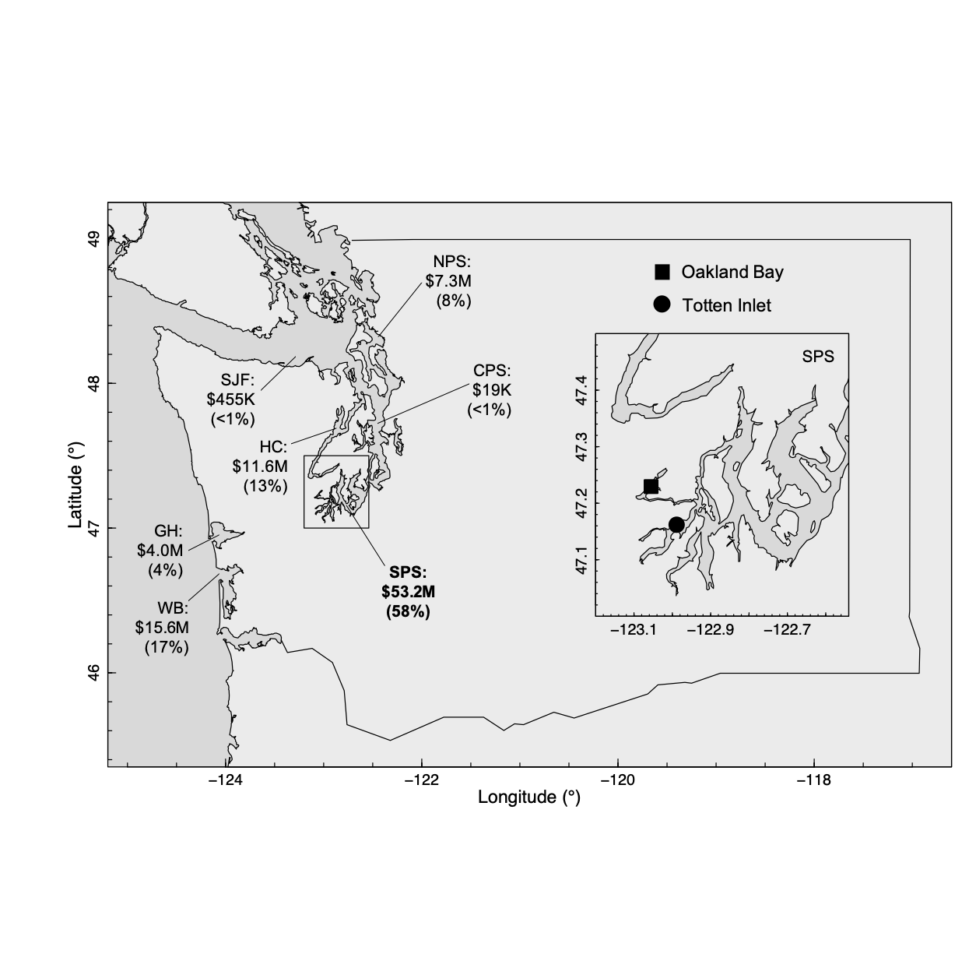

**Figure 2**

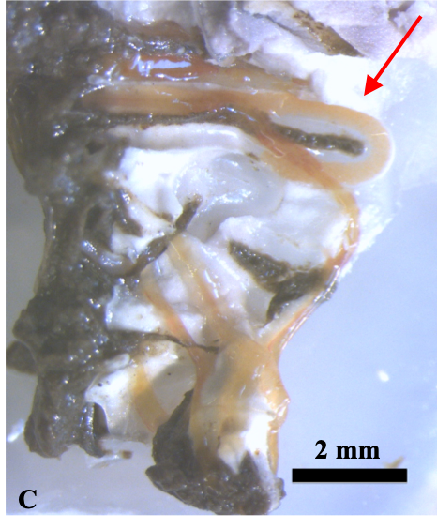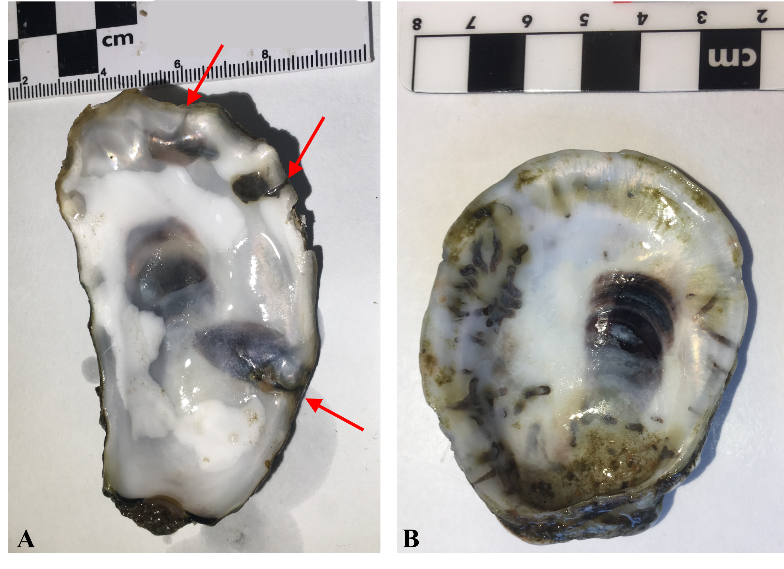

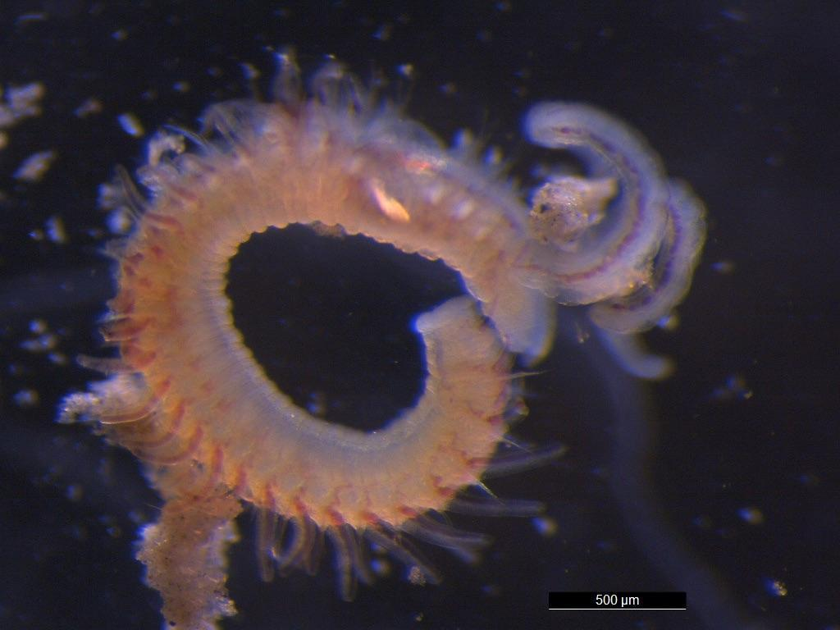**Figure 3**

**Figure 4**

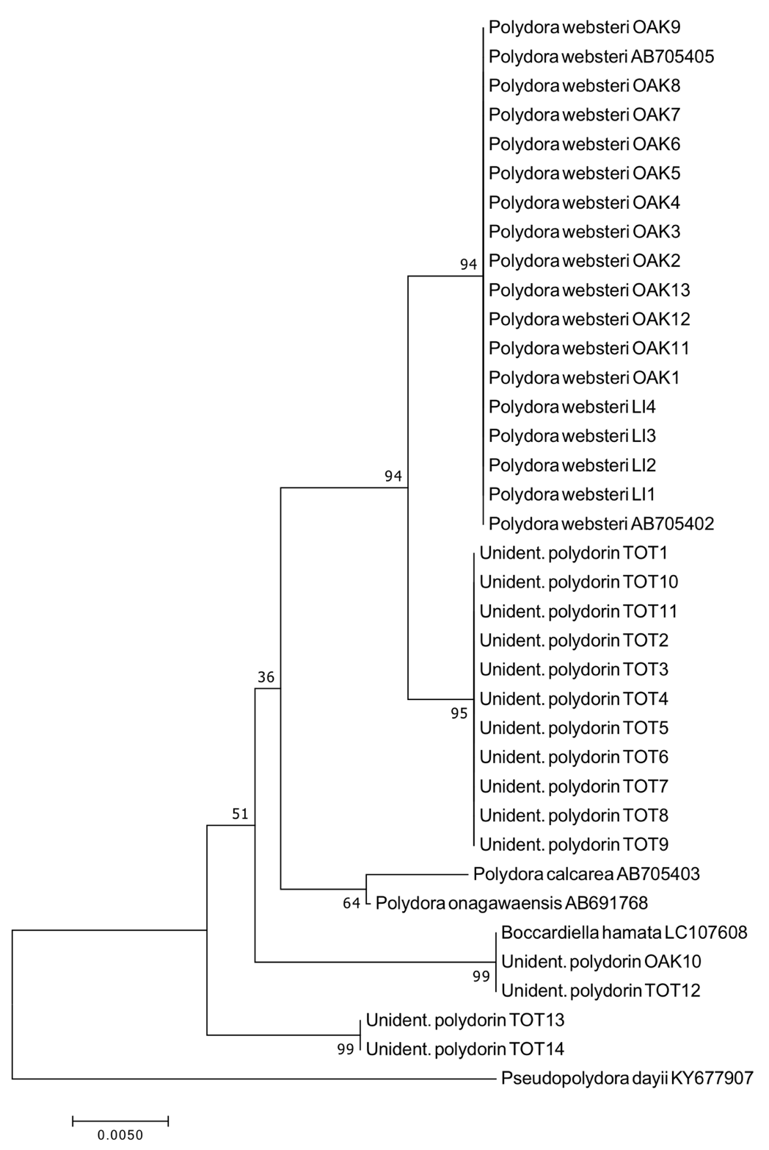

**Figure 5**

